Itotec Cutters – Since 1919
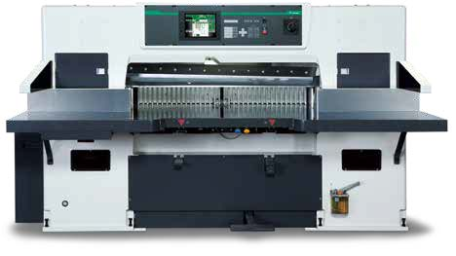
Itotec, manufactured in Japan, has been producing Paper Cutters, and Ancillary Cutting equipment for over 100-years. Headquartered in the city of Nagoya – home of Toyota – Itotec is a 6th generation family business with an install base of more than 10,000 Paper Cutters worldwide.
Best Graphics (Wisconsin, USA) is the importer, distributor and post-sales parts & service provider of Itotec equipment. Cast from single-piece frames, Itotec is proud to be identified as the original double-arm Paper Cutter.
Itotec’s main competitor is, and always has been, Polar. However, Itotec Cutters outperform Polar Cutters in essentially every category. From weight of the Cutter down to the price. When looking at both Cutters side-by-side, the biggest visual difference is the screen size. To many this is perceived as a benefit of the Polar Cutters. Best Graphics would beg to differ. Let’s dig deeper…
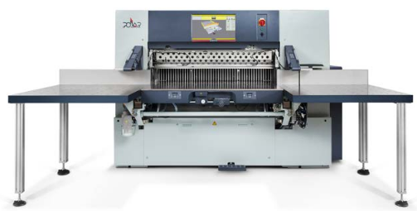
Polar Screen & Programming

New Polar Cutters come equipped standard with an 18.5” touch screen display. Yes, visually this looks nice, however, we ourselves have owned a Polar N 115 Pro model on trade and can confirm they’re not as user friendly as the Itotec Screen. Please note that the following information is based off of our service team’s assessment of the Cutter when it was in our shop.
For More Information
+1 (262) 522-3330
Sales@bestgraphics.net
www.bestgraphics.net
On the Polar, when an operator is looking to make a change to a cut while running a job there are a number of un-necessary steps that are involved. Hypothetically, let’s say that the operator is running a job and would like to make a change to the 12th cut for the job. The operator has to complete the following steps to do complete this task: 1. Back out from the run screen. 2. Go into the programming screen. 3. Scroll down and select the 12th cut 4. Enter the desired cut 5. Save the cut 6. Back out of the programming screen. 7. Go back into the running screen. 8. Scroll down to the cut the operator had changed and then proceed with the job.
Now for comparison, let’s walk through the same procedure for a job on an Itotec Cutter. While the operator is running a job, they are able to stay in the same screen to make the change to the 12th cut. 1. Scroll down and select the 12th cut. 2. Using the 10-key pad to the right, enter the desired cut. 3. Press Enter to Save. The operator will now resume right where they left off in the job prior to changing the 12th cut. It is as simple as that. With an Itotec there are not multiple window popups making navigation very operator friendly. This same process holds true for other functions when using the Polar Cutter as well. There are quite a few unnecessary steps that drag out changing settings and measurements due to the constant changing of screens.
Bigger is Not Always Better
Itotec unveiled their new SC Series Cutters in 2019. The SC Series Cutters have a 10” screen and increase from 8.4” on the eRC series. Yes, the 10” is still considerably smaller than the 18.5” screen of the Polar Cutter, however the overall total screen usage of the Polar is very minimal for necessary usage. Best way to describe this is to think about opening various browsers in Windows and wanting to view the multiple screens all at the same time. You are not going to be able to have full screen viewing to all the windows.
What a buyer of the Polar Cutter is essentially paying for is the “Process Visualization” during the cutting process. These visuals include the clamp going up/down, back-gauge movement, and knife cycle which is something the Itotec does not display.
Furthermore, it is also worth noting that the Polar screen is set a little deeper. For shorter operators this could pose as an issue due to the need to reach further to access the screen.
Polar has a nice feature that gives a visual of the knife change process on the screen. However, the knife change/adjustments on a Polar occurs at the back of the cutter so the operator would not easily be able to utilize this feature. Itotec’s knife changes/adjustments happen at the front of the cutter which is considerably easier.

