Itotec Paper Cutters – Since 1919
Itotec, manufactured in Japan, has been producing Paper Cutters, and Ancillary Cutting equipment for over 100-years. Headquartered in the city of Nagoya – home of Toyota – Itotec is a 6th generation family business with an install base of more than 12,000 Paper Cutters worldwide.
Itotec Paper Cutters can be purchased stand alone or in any combination with Ancillary equipment. Those complimentary pieces typically could be a Paper Lift, Paper Jogger and/or an Unloader for down stacking.
Our Itotec Cutters are the most efficient in the industry all by themselves but in combination with one or more of the Ancillary items above, the productivity of the Cutter is greatly increased. Just the addition of a Lift and Jogger can potentially increase the throughput of the Cutter by 50%. When an Unloader is added to a Cutting system, your throughput can nearly double.
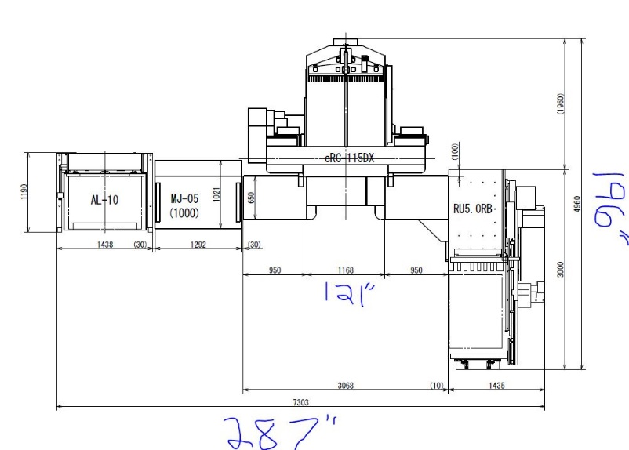
Frequently Asked Questions
eRC-115DX | 15’ 5” x 21’ 5” (L x W)
Q. Are Equipment Layouts flexible to fit the floor space you have available?
A. Yes. Several layouts are possible to fit any floorplan. As you see on the Right side of the page, you can set up any combination of pieces. The examples at Right are U Shaped, L Shaped and Cutter with waste conveyor only layouts. The systems can be setup to run from Left to Right or Right to Left. Please note the unloader is direction specific and we need to know which side you require when we order.
121 inches
196 inches

Q. Can the Ancillary equipment be added at a later date if you want to upgrade your cutter to a system?
eRC-115DX | 23’ 11” x 16’ 4” (L x W)
(287 inches)
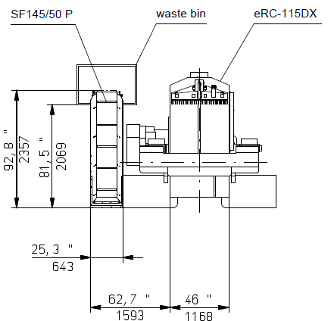
- Yes, you can upgrade your cutter by adding any combination of ancillary pieces. If space needs to be made on either side of the cutter to add the other pieces, it can be moved with a large fork truck.
eRC-115DX | 9’ x 7’ 9” (L x W)
For More Information
+1 (262) 522-3330
Sales@bestgraphics.net
www.bestgraphics.net
Review:
✔ | Several Layout Combinations
✔ | U Shaped System for Corner or Center of Room
✔ | L Shaped System for a Corner or Along a Wall
✔ | System Components are Ala Carte and can be added after initial Purchase
✔ | Full Cutting System Increases Cutter Output by 100%
✔ | Size Difference between a 45” and 54” system is only about 12”
