Itotec SC Series Cutters – Since 1919
Itotec, manufactured in Japan, has been producing Paper Cutters, and ancillary Cutting equipment for over 100-years. Headquartered in the city of Nagoya – home of Toyota – Itotec is a 6th generation family business with an install base of more than 12,000 Paper Cutters worldwide.
Best Graphics (Wisconsin, USA) is the importer, distributor and post-sales parts & service provider of Itotec equipment. Cast from single-piece frames, Itotec is proud to be identified as the original double-arm Paper Cutter.
Introduced at JGAS 2018, Japan’s version of Printing United, the SC that will succeed the eRC Series, which has been on the market since the early 2000s. The SC Series will continue to be the most robust cutter on the market, adding new features that only make it better.
FAQ
Q. Are all the adjustments and knife changes still done from the front?
A. Yes, like the eRC Series the SC Series still has all the knife adjustment/changes done from the front of the cutter.
Q. Were there any changes to the overall size?
A. No, the machine layout has stayed the same as well as the overall weight of the equipment.
Change is Good
With the SC Series Paper Cutter, Itotec has made enhancements that help improve operator efficiency and machine safety.
One of the noticeable improvements is the increased screen size to 10” up from 8.4”. The ease of operating this touch screen has been kept the same with tabs like machine diagnostics, job saving and preventative maintenance still there. Another visible difference is that the front ‘access windows’ are changed to safety interlocked doors opposed to having to fully remove the plates. This allows them to be opened or closed with a single hand. Safety sensors are now on the edge of the cutter which gives more space when exchanging knives from the front of the cutter.
For More Information
+1 (262) 522-3330
Sales@bestgraphics.net
www.bestgraphics.net
The major changes are actually with the performance. The knife speed and back gauge speed are greatly improved. The knife speed increases from 42 cuts per minute to 50 cuts per minute. While the back-gauge speed increases from 8.85” per second to 11.8” per second. Lastly, clamp pressure has been increased from 8,800 to 9,900 lbs./sq. in. which improves cutting accuracy of board and vinyl materials.
Additional Features
The new SC Series also has increased safety features. The safety beam guard has been widened which allows for safer operation and knife changes.
Lower waste removal windows have also been added which allows for quick removal of paper waste that occasionally drops inside the machine.
Overall, function and ease of maintenance, and additional ease of knife height adjustment and knife replacement are improved.
Key Differences:
✔ | Increased screen size: 8.4” to 10”
✔ | Increased knife speed: 42 to 50 cuts per minute
✔ | Increased back gauge speed: From 8.85” to 11.8” per second
✔ | Increased clamp pressure
✔ | Supports data input/output with USB memory
✔ | Safety sensors are now on the edge of the cutter
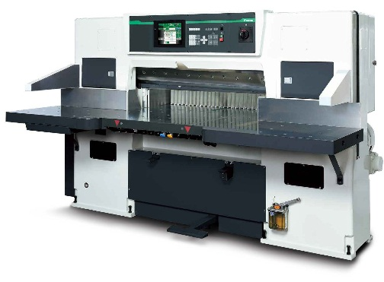

New Itotec SC Series Cutter Listings
New Itotec SC Series Brochure
Best Graphics began installing the New SC-115 mode back in 2019. To date, we have had no return service calls.
On all new Itotec Paper Cutter purchases, Best Graphics offers the industry best 5-year parts and labor warranty. Itotec Cutters have the lowest cost of ownership due to the sound engineering and Best Graphics’ support.

