Laserck Offline Blankers – Since 1982
Laserck Corporation, headquartered in Osaka, Japan, has been the premier supplier of Offline Blanking in Japan and Southeast Asia for over 35 years. With their highly patented design, Laserck has over 100 Offline Blanking systems installed worldwide.
The Laserck BLK has many attributes that contribute to making the machine a huge money saver and production enhancer. One of the highlights is the ability to makeready the machine in as little as three minutes….TO BLANK
The Laserck BLK Offline Blanker is an incredibly efficient machine and the makeready process is a large part of that. When compared to a traditional Blanker makeready that can take several hours to prepare, the BLK makeready can be as little as three minutes for a repeat job. A new Blanking job should take no longer than 20 minutes from the last sheet of job A to running production on job B. Along with the cost of the templates (pennies), the BLK makeready provides a very efficient way to scrap, especially on short run jobs.

How to Makeready a Laserck BLK
Q. Is the Laserck BLK makeready quick and easy?
A. The Laserck BLK utilizes templates that simply slide into the top and bottom pin plates. There is no other registration to do. Cycle a few sheets to test and you are ready to run
Q. Is there top and bottom tooling alignment to perform as with a traditional Blanker?
A. No, there isn’t. The templates make sure the alignment is all done.
Q. How is the paper path aligned to the pins?
A. With the use of the pin placement Mark IV software in the prepress department. While making sure the best pin placement to the blanks is used, the side guide and gripper positions of the sheet are automatically saved. When the job is called up to run, the sheet position is set from the prepress software.
Q. Does the auto palletizer require extensive makeready?
A. No, the only setup for the auto palletizer is to place the pallet in the correct position on the floor.
Q. Do I have to manually change the pins?
A. No, it is automatic with the use of the templates.
Q. I’ve heard of Kawahara, but never Laserck.
A. Kawahara has been the only manufacturer of full sheet Offline Blankers until now. Laserck has been manufactured and distributed in Japan since 1982 and they are now making their machines available to the rest of the world. The Laserck UT, the least automated machine in the Laserck lineup, is similar to the Kawahara. The Laserck BLK and CBL models far exceed anything that Kawahara has produced. Laserck accels in design, makeready efficiency and production. Truly not even in the same class.
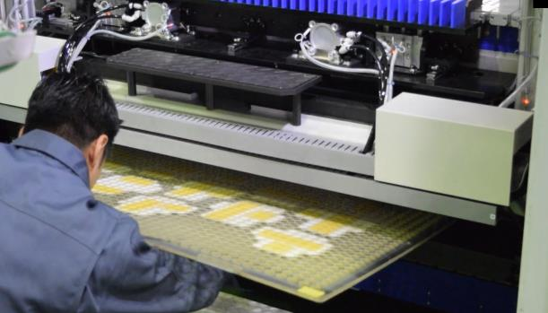
Figure 1 – Bottom Template Makeready

Testing Process
During the makeready of the Laserck BLK, the templates from the previous job are removed and replaced with templates for the new job. At this point the pins are positioned automatically. The stock from the old job has been replaced by the stock for the new job and the auto palletizer switch has occurred. The operator goes over to the computer, selects the new job in the software, then uploads that job. The feed table and side guide are set, and the test is ready to happen.
The reason for the test cycle is to make sure that the upper pins are not hitting the good product and the bottom pins are not damaging the bottom of the stacks of good product. This is typically done with a short (maybe ¼” or ½”) stack.
Makeready Advantages
As stated above, the makeready time of the Laserck BLK is 5 to 20 (or more) times less than a traditional Blanker. With this advantage, shorter jobs can be blanked and more jobs per day can be processed.
The cost advantage is thousands of dollars with the low cost of the machine and templates costing only pennies. Quick makereadies and fast scrapping allow for more jobs and shorter run jobs to be completed automatically. They are now ready for the folder gluer or next process. The machine pays for itself in savings alone!
The Laserck BLK will easily support 1,2,3 die cutters worth of production. With multiple die cutters, the savings per job goes even higher!
Review:
✔ | Full makeready for a new job should take no more than 20 minutes
✔ | A repeat job makeready can be as little as 3 minutes
✔ | Template preparation is completed by the prepress department
✔ | Feeder and delivery stacks can be switched by a floor person while templates are changed
✔ | Template pin placement is done prior to the making of the template so the Laserck can be up and running as fast as possible
✔ | One or maybe two small stack cycles for quality check and the job is running at full production
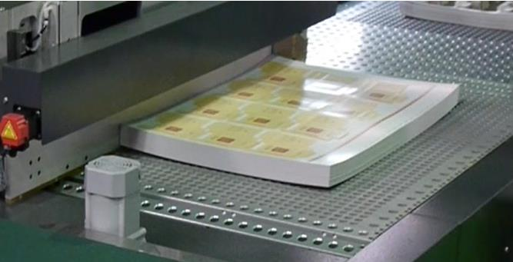
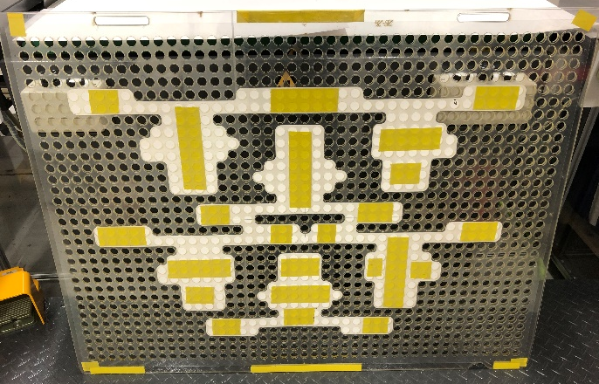
Figure 3 – Stock on Register Board
Figure 2 – Template in Grid

