Best Graphics – Since 1978
Best Graphics is North America’s largest independent importer and distributor of Bindery, Packaging, Finishing, and Pressroom equipment with over 40 years of experience. Best Graphics also offers post sales parts and service support throughout North America out of our two metro-Milwaukee based facilities.
Folder Roller Recovery
The folder rollers are the most important part of the folding machine. Today, most are made from a combination of steel and urethane or rubber. Even though they are made of durable materials, they still sustain wear with use over time.
Benefits of Updated Rollers
- More consistency in the fold
- Makeready is faster with fewer adjustments
- Paper jams are less frequent, thus less waste
- Quality of the fold is better
- Run speeds are higher
- Quieter machine
Roller Materials
Rubber (Black) – Good grip and very good wear properties.
Foam (White) – Great control over very slick stocks, but wears faster than the others.
Urethane (Brown) – Good grip and very good wear properties. It is resistant to oil-based lubrications.
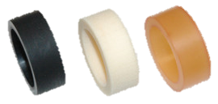

Recovery vs. New Roller Cost
Recovery - $50 per segment/collar
New Roller - $400 - $650 per roller depending on size
Exit & Scoring Wheels - $80 per roller (Doesn’t always need to be completed)
General Recovery Process
For More Information
+1 (262) 522-3330
Sales@bestgraphics.net
www.bestgraphics.net
Segmented Rollers (Stahl & Heidelberg):
- Roller are first inspected to see if recovery is warranted
- If recovery is possible then the rollers are stripped and cleaned
- New urethane, foam, or rubber is applied
- Roller is straightened and ground
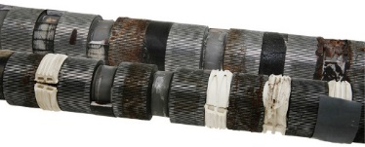

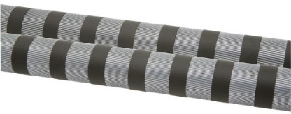

Spiral Rollers (MBO):
- Rollers are inspected to see if regrinding is possible. Excessive journal wear or roller body wear generally makes the roller non-repairable
- Roller is straightened and reground to manufacturer’s specifications
- New bearings installed
- Note: Generally, more cost effective to replace rollers versus recover
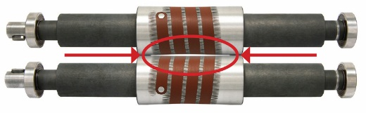

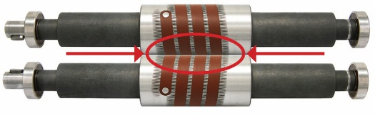

Do I Need New Rollers?
An operator can tell if rollers need to be recovered if the rubber or urethane are 1). hardened or 2). below the steel.
A good way to test if you need to update the rollers is to insert a strip of light stock at each end of the roller and set it evenly for a light drag. Then insert (3) strips: (1) at each end and (1) in the middle. If the middle sheet has no grip, then it is time to recover the existing rollers or purchase new rollers
In some cases, recovering rollers is not an option. If there is excessive “journal” or “knurl” wear then the roller is not a candidate for recovery. Also, if the roller shaft is bent, the roller cannot be recovered, and it is simply time for new rollers all together.

