Osako Saddle Stitchers – Since 1916
Osako, manufactured in Yamagata, Japan, has been producing Saddle Stitching systems for over 50 years. Osako has been represented by Best Graphics for over 20 years and has over 3,000 installations worldwide.
Back Story – Our First National Product Line (1995)
We were contacted by Osako Japan in the early ‘90s. Osako was looking for a new North American agent for their Saddle Stitchers. Previously marketed as Consolidated Stitchers, we decided to set up distribution for sales and service, and utilized trained Osako/Muller technicians located in the States. This was Best Graphics first direct import product for national distribution, and our first step outside of regional sales.
The biggest concern was how do we support a national line out of Milwaukee, WI?! 25 years later, the answer is if it’s a high quality and proven Japanese product, the service quotion is negligible. In fact, we still offer a three-year warranty on all Osakos – (1) year from the manufacturer and (2) from Best Graphics.
The rest is history. Our 25+ years as the U.S. agent stretched our product reach and was a building block for additional national importing. Today, Osako continues to capture worldwide marketshare. Worldwide installs number in the thousands.
Three Models
Our partner Osako offers three distinct models – all with “bullet proof” make ready automation – and modularity in respect to choice of automation and trimmer specification. Trimmer options include face trim first or last models, as well as our new “Duo” trimmer with an unprecedented 15 second activation/deactivation of the second stage 4th & 5th center knife.
And while other manufactures are obsolete - we still support all machines sold including legacy machines and provide free phone support.
With a perfect record for 100% customer loyalty – higher speed offerings expected – Osako provides the best in Saddle Stitching performance, durability and value.
Independent Import Agent – What We Like About Representing Osako
- Durable, well-engineered mechanics
- Bulletproof electronics
- Multiple models
- Better price points
- 50-year manufacturing legacy (25 via Best Graphics representation)
- Proven track record
- Easily supportable directly, internally or via third party service (we are very transparent for technical support documentation)
- Open electronics architecture. Easily modifiable (ie it’s not proprietarily controlled)
- Manufacturer is very agent/customer oriented – we get answers quickly
We’re in this together…
Customer – What You’ll Like About Owning an Osako
- Easier makeready and set up
- High floor speed capability
- Much tighter control of the signature feeders
- Better cover feeder design from the lightest to heaviest covers – tighter and cleaner scores (technifold standard) individually folded without cracking or marking
- Heavier duty Stitcher sled and mechanics with oil bath lubrication (more metal, less plastic)
- Heavier duty Three Knife Trimmers. Face first or face last design. Manual or automated set-up. With new “duo” series 2 stage trimmer, 15 second activation/deactivation of 4th/5th center knife unit. Modular build – more price points.
- Japanese build, quality mechanics/electronics
- No nonsense, quick response, direct support. No extra charge for standard phone support (no need for a “contract” for support)
- Lowest cost of ownership… period!
Track Record – How About 100% Loyalty!
In our 25-year history as the Osako import agent we have installed hundreds of Osako’s – new, used and reconditioned. During this time, anyone who has bought their first Oskao has always stayed loyal within Osako’s range for their subsequent 2nd, 3rd, 4th… Stitcher purchase.
We welcome customer reference requests. Attached is a brief list of customer installs and regional placements.
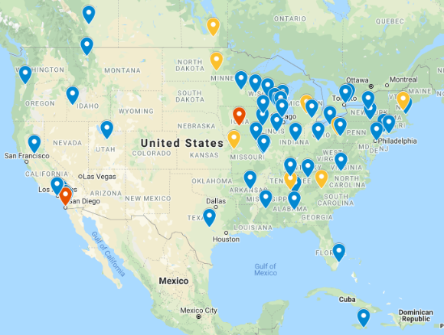
Recent Installations

