Palamides Bander Deliveries – Since 1972
Palamides, founded in Stuttgart, Germany, manufactures automatic banding deliveries and stacking deliveries. With over 3,600 installs worldwide, Palamides is globally recognized in the Graphic Arts market.
Palamides is the premiere automatic delivery for Folders, Saddle Stitchers, and other machines. They offer a wide range of equipment that can band, stack or do both simultaneously.
 | 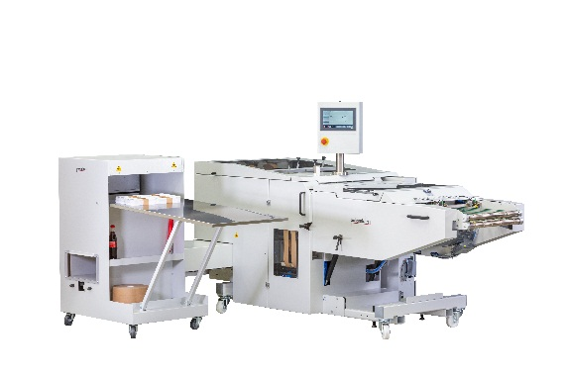  Delta Series | 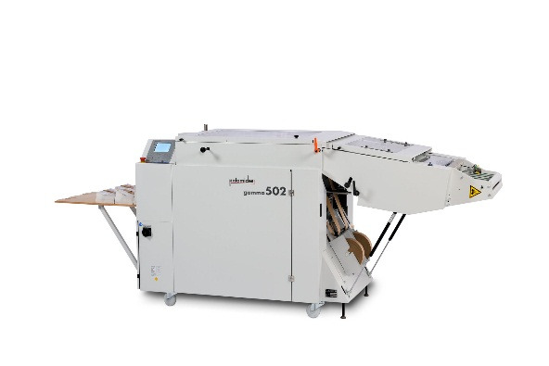  Gamma Series | Mitra Series  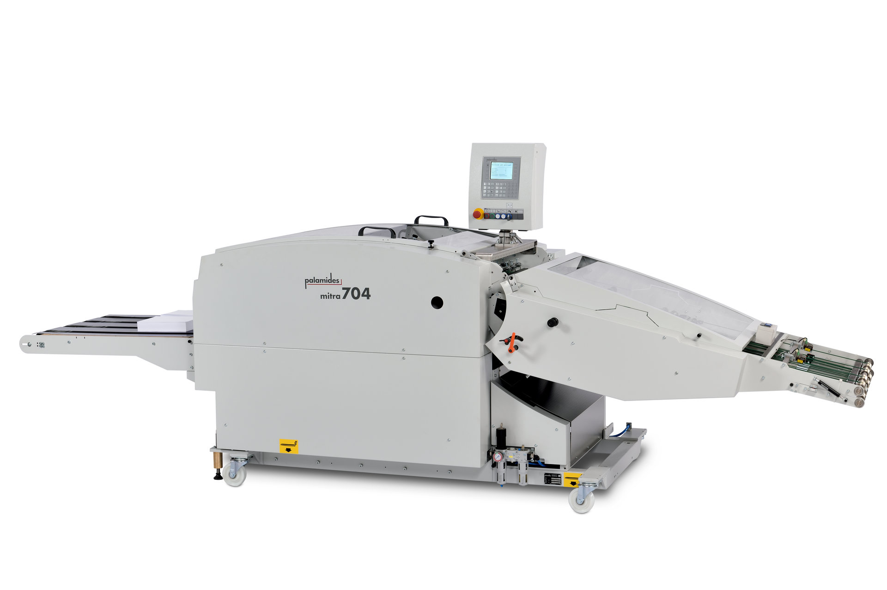
Models | Delta 502  Delta 703  Delta 705 | Gamma 502 | Mitra 500  Mitra 700
Function | Bander | Bander & Stacker | Sheet Stacker
Performance | 600 Bundles/Hour per Stream | 600 Bundles/Hour per Stream | 800 Stacks/Hour
Number of Streams | Delta 502: 2  Delta 703: 3  Delta 705: 5 | Gamma 502: 2 | Up to 6
Max. Format Ranges | Delta 502: 12.59” x 20.86”  Delta 703: 12.59” x 31.49”  Delta 705: 12.59” x 31.49” | 9.25” x 20.07” | Mitra 500: 14” x 20”  Mitra 700: 14” x 30”
Min. Format Ranges | 2.75” x 4.13” | 3.74” x 5.51” | 4.75” x 4.75”
Band Width | Delta 502: 1.96” (50mm)  Delta 703: 1.96” (50mm)  Delta 705: 1.18” (30mm) | 1.96” (50mm) | N/A
Stack Height | Minimum: 0.39”  Maximum: 5.9” | Minimum: 0.78”  Maximum: 4.72” | Minimum: 0.78”  Maximum: 7.87”
Machine Dimensions | Delta 502: 8.9’ x 7.3’  Delta 703 & 705: 8.9” x 9.1’ | 11.2’ x 3.2’ | 13’ x 9.8’
Banding Materials | Kraft Paper & LDPE | Kraft Paper & LDPE | N/A
Pressing Station | 3.5 Tons | 1.2 Tons | N/A
Products | Signatures, Flyers, Brochures, & Mailings | Signatures, Flyers, Brochures, & Mailings | Single Sheets, Dies & Blanks
Optional Features | - Anti-Static Device  - Small Format Device  - Air Blast  - Extension Buffer | - Anti-Static Device  - Small Format Device  - Air Blast  - Extension Buffer | - Anti-Static Device  - Bar Code Reader  - Air Blast  - Camera for End of Set
Compatible Equipment | Saddle Stitchers, Folders, Mailers, and more | Saddle Stitchers, Folders, Mailers, and more | Digital Printers, Die Cutters, Rotary Cutters, and more

