Palamides Bander Deliveries – Since 1972
Palamides, manufactured in Stuttgart, Germany, has been producing automatic Banding Deliveries and Stacking Deliveries for over 45 years. With over 3,600 installs worldwide, Palamides is globally recognized in the Graphic Arts market.
Palamides is the premiere automatic Delivery for Folders, Saddle Stitchers and other machines. A range of different machines are offered with some banding, some stacking and one is a combination machine that can perform stacking only OR stack and band, at a touch of a button. With inline pressing stations on all models, the folded or bound piece is as flat as it will be and will stack very properly. For automatic Banding Deliveries, Palamides offers the Delta series in models 502 and 703 and the Gamma 502. The stacking only units are the Mitra series, 500 and 700. The combination machine is the previously mentioned Gamma 502 which can stack only or stack and band.
Which Machine?
The first decision that needs to be made is do you want to band the product. If so, the Delta or Gamma units are the choice. If you require stacking only, the Mitra or Gamma series is your choice. The next choice is the maximum width of the stock being input to the chosen machine. Each machine from Palamides, no matter which function, can accept one and two stream output. The Delta 703 has the ability to run up to 3 streams and Mitra 500 and 700 can process one or two streams with the option of four or six stream capability for the 700.
Mitra Series
The Delta 502 and 703 are banding machines and we will concentrate on the Mitra and Gamma here.
For More Information
+1 (262) 522-3330
Sales@bestgraphics.net
www.bestgraphics.net
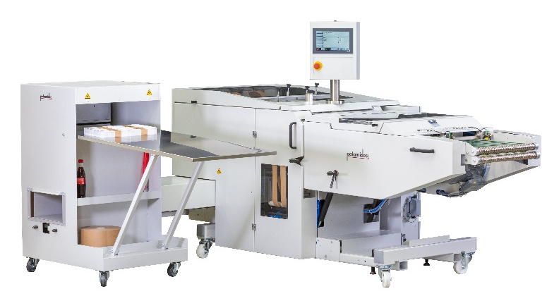
With the accelerating and widening use of digital printing technology, the need for automated cutting and stacking has come for to the forefront. The Palamides Mitra accepts the single sheet printed pieces and assembles them in perfectly stacked lifts. The streams can be multiple with standard being one or two streams and four or six optionally. The format of the Mitra 700 is up to 30” side and the Mitra 500 at 20”. The sheet length is automatically set with the keypad for faster setup of a new job. Bar code recognition defines the end of the previous set and the start of the next. Applications for the Mitra series of sheet stackers would be from XY slitter, check printers, statement printers just to name a few.
Gamma 502
The Gamma 502 was introduced in fall of 2019 and is a new concept for Palamides. The Gamma can stack only or stack and band and accepts 4 page signatures up to 10mm thick booklets and any thickness in between.
The process involves an integrated counter, length inspection system with reject (if needed), pressing station, stacker, bander (if necessary) and a buffer table to separate the stacks and bring them to the operator in an orderly manner.
Many printers utilize the banding capability for in-process needs allowing more manageable and neat transport and use of the lifts of folded stock. Applications would be signatures for a Saddle Stitcher or Perfect Binder, maybe a mailing inserter or inkjet machine.
The infeed of the Gamma is height adjustable so it can go from the folder to the Bookletmaker or the Saddle Stitcher in no time at all.
Both the Gamma and Mitra are running in a straight, with the paper path, direction. This saves a tremendous amount of space on the plant floor allowing for additional machinery in the plant if needed.
Review:
✔ | Band, Stack or Combination
✔ | 20” wide and 30” Wide
✔ | 1 up, 2 up or 3 up
✔ | Up to 600 cycles per hour
✔ | Batching with different color banding
✔ | One Operator for entire feeding and Delivery process
✔ | Able to deliver behind many different machines

