Wohlenberg Perfect Binders – Since 1946
Wohlenberg, manufactured in Verden, Germany, has been producing Perfect Binders, Gatherers and Three-Knife Trimmers for over 70 years. Having developed the first Perfect Binder and Three-Knife Trimmer, Wohlenberg is a global leader in developing and manufacturing quality Perfect Bindery equipment.
Wohlenberg provides options for Perfect Binders with PUR and/or EVA adhesives. Ethylene-vinyl acetate (EVA) has been around for a long time and many industries are comfortable with it, but polyurethane reactive (PUR) is becoming more popular. It is important to know the difference between the two so you can make the best possible decision for your bindery.
EVA (Ethylene-Vinyl Acetate)
EVA gluing (A.K.A. Hotmelt gluing) is an inexpensive method that is predominantly used with offset and web stocks. EVA glue is able to be left in the machine and reheated at any time, making it ideal for small-format Perfect Binders. Both the equipment and adhesive are less expensive than PUR. EVA is a great option for standard operations because handling the adhesive and maintaining the glue system is much easier than with PUR. EVA has fast curing times, which allows binderies to have faster turnaround. Binders using EVA have the option to “notch bind” their books, which is not recommended for PUR. EVA glue is thicker, allowing for greater penetration in to the spine.
PUR (Polyurethane Reactive)
PUR adhesive is becoming more popular as it can be used to bind varnished, UV-coated, carton, mylar and other difficult stocks that EVA may struggle with. It can also be used with tough papers, cross-grained stocks and higher-basis weight recycled papers. PUR is also a good fit for digital printing because it isn’t affected by ink migration. PUR makes higher quality books, allowing for better lay-flat and flexibility, especially for larger books. Page pulls are 40-60% higher with PUR. Less PUR adhesive is needed for gluing, which helps prevent adhesive creeping out during the nipping process.
For More Information
+1 (262) 522-3330
Sales@bestgraphics.net
www.bestgraphics.net
However, curing time for PUR is longer than EVA. Many binderies wait a full 24 hours before shipping finished books. PUR equipment is more expensive and requires more maintenance, as the system needs to be sealed every night to prevent the glue from curing. PUR can also emit MDI (diphenylmethane diisocyanate) during the curing process which may cause allergic reactions to the skin and respiratory issues. But, MDI levels drop drastically once substrates are joined, so this is mainly a concern during preventative maintenance. Tools are available to test MDI levels in a facility. Venting and other methods can be used to lower MDI levels.
Which Option Should I Choose?
EVA and PUR glue systems are both widely used and both have their benefits, so when choosing between the two you need to consider which will be more suitable for the types of jobs you typically run.
- Do you do a lot of digital printing or runs of difficult stocks that EVA may struggle with?
- Do you want better lay-flat?
… Then PUR Gluing may be the right choice for you!
- Do you want a low maintenance system?
- Are you looking for a cost effective option?
- Do you want faster curing times?
- Do you want to be able to notch bind books?
… Then EVA Gluing may be the right choice for you!
Let’s Compare
 | EVA | PUR
Least Expensive | ✔
Lower Maintenance | ✔
Fast Curing | ✔
Better Lay-Flat |  | ✔
Digital Printing |  | ✔
Difficult Stocks |  | ✔
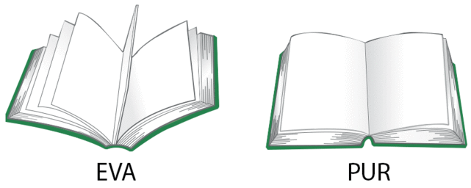
As you make the decision between EVA and PUR,
feel free to contact Capital Adhesives
for current adhesive pricing:
Capital Adhesives (Mooresville, IN)
Randy Levanke
+1 (317) 834-5415
rlevake@capitaladhesives.com
www.capitaladhesives.com
