STOCK Litho Laminators – Since 1970
STOCK, manufactured in Frankfurt, Germany, has been a leading producer of Sheet-to-Sheet Mounter and Labeling machines for 50 years. With speeds up to 8,000 per hour, STOCK machines are highly regarded for their accurate registration, tight tolerances, German manufacturing standards, and high quality finishing.
STOCK Mounter/Laminators are ideal for mounting substrate sheets to litho printed labels/sheets and ensure the tightest tolerances in the industry. All STOCK units are modular in design, and thus can be automated from the start, or scaled in the future. With the design of each machine, the model name is simply a construction of which modules are required. The following resource will help you understand each STOCK module.
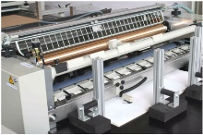
A | Automatic Glue System
The automatic glue feeding system is included as standard. Adhesives with a white resin (PVAc) or starch base can be used. A minimum amount of glue is applied to produce flat sheets. Glue consumption is dependent on type of paper (board), content of humidity and adhesive. An integrated sensor detects and registers the glue label and the gluing unit automatically feeds the glue onto the label. During breaks in working or other machine stop periods, the gluing unit, driven by a separate motor, carries on running. A stripping needle bar is used to prevent the substrate sheets from wrapping around the glue application roller.
1 | Laminator
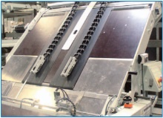
The laminating section aligns the sheet against the side guide and mechanical head stop for precise registration. Laminating materials should have a smooth, flat surface and be square and clean cut with an even overall thickness.
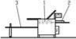
2 | Feeding Table (Manual)
Single sheet label feeding table for manual feeding. Requires approximately 2 people.
3 |Take-Off Table (Manual)
For More Information
+1 (262) 522-3330
Sales@bestgraphics.net
www.bestgraphics.net
Manual delivery section. Sheets pile up on a simple delivery table and are stacked on a pallet by hand.
4R | Substrate Sheet Feeder
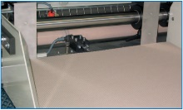
The substrate sheet feeder utilizes a non-stop 4R suction belt feeder to increases production speeds. Machines with the substrate sheet feeder only requires approximately 1-2 people compared to 2-3 workers required for hand fed machines.
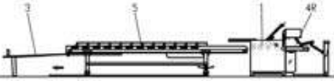
5 | Pressure Belt
The pressure belt flattens the sheet, allows the adhesive to properly cure and assists in the removal of bubbles and creases. This improves the quality of the finished product. The belt has a variable speed so the pressure drying time is adjustable. This leads to savings in adhesive and improves the sheet flatness.
6 | Printed Sheet Feeder
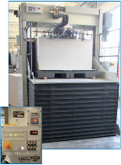
The optional Mabeg printed sheet feeder is available for superior production and tighter registration requirements. Smaller sheets result in increased output as they can be fed faster. An optional pre-loading device is available.
7 | Non-Stop Down-Stacker
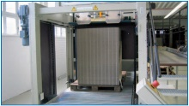
Automatic down-stacker with non-stop operation for accurate sheet stacking. Pile delivery.
8 | Flip-Flop (Batch Pile Turner)
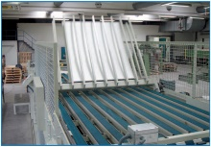
An optional flip-flop batch pile turner is available with three modes depending on sheet flatness after lamination: 1) alternate inverting, when the sheets are warped; 2) without inverting, when the sheets are flat; 3) always inverting.
Common Machine Offering
A-134R5/1500
