Wohlenberg Quickbinder – Since 1946
Wohlenberg, manufactured in Verden, Germany, has been producing Perfect Binders, Gatherers and Three-Knife Trimmers for over 70 years. Having developed the first Perfect Binder and Three-Knife Trimmer, Wohlenberg is a global leader in developing and manufacturing quality Perfect Bindery equipment.
Traditionally known for their heavy duty, full system Perfect Binding lines and Three Knife Trimmers, Wohlenberg’s German built handfed Quickbinder model is often overlooked. With the growth of digital print, it is more important than ever to ensure you have a solution that addresses the need for personalization or variable print. The below will highlight some of the Quickbinder Digital Edition’s marquee features.
(3) Quickbinder Offerings
Feature | Basic | Universal | Digital
Speed | 2,000/Hour
EVA Glue | ○ | ○ | ○
PUR Glue | ○ | ○ | ○
Cold Glue | − | ○ | −
Gauzing | − | ○ | ○
Integration | − | ○ | ○
Delta 10 | − | − | ●
CBM | − | ○ | ○

● = Standard | ○ = Optional | − = Not Available

Digital “Delta 10” Technology
The Wohlenberg Quickbinder’s “Delta 10” technology supports variable page thickness books by adjusting the arriving clamp of the Perfect Binder by +/- 10mm (.393”) from the previous book thickness. These changes are done intelligently, on-the-fly without the need to stop the machine:
- Clamp opening/detection (for each variable thick book block)
For More Information
+1 (262) 522-3330
Sales@bestgraphics.net
www.bestgraphics.net
- Gluing coverage (as thicker books will require a wider strip of glue)
- Cover placement/alignment
- Book pressing/nipping
- Delivery of the books (onto a conveyor or returned to the operator)
Delta 10 In Theory
Let’s say the first 8.5” x 11” book block has a thickness of 10mm (.393”). The second book can have a thickness of up to 20mm (.787”). Thereafter, let’s say the third book block the operator loads is 15mm (.590”). Great, no problem; the Quickbinder automatically self-adjusts. The fourth book fed is 21mm (.826”), which is +/- 6mm, so accepted. The next, 11mm (.433”) – +/-10mm from book four – so approved.
Delta 10 In Practice
When the first book block is fed into the clamp, measurements will detect the product’s thickness. This data is forwarded on to the side gluing unit for automatic calibration. Similarly, the book’s measurement is sent to the cover feeder for automatic calibration of the Quickbinder’s crease-score widths. A second book block, of a varying thickness is inserted and the procedure repeats intuitively. No operator adjustment, or engagement is required between books!
Cover Book Matching (CBM)
Consider our CBM technology if you are personalizing the covers of each book block. With this option, the first Winspector camera scans the barcode on the book block. The Winspector camera two reads the cover and ensures it matches the barcode of the book block. In the event the covers are out of sequence, the Binder will stop and notify the operator of the error via the Navigator touchscreen.
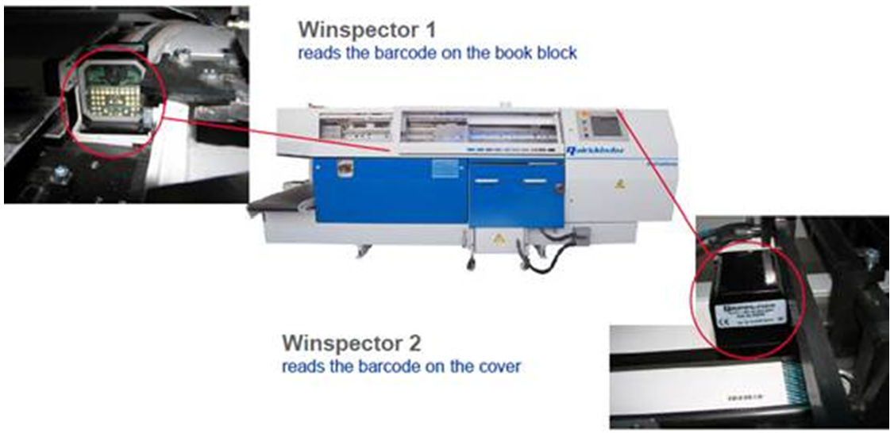
“Pushing” JDF Format from MIS
Given the amount of data associated with variable print work, we have an option to “push” the JDF details of each personalized book from your MIS system to our Quickbinder. Ask your Sales Representative to line item this inexpensive, $2,500 option on your quotation!
Watch a Video of a Quickbinder In Action!

