**Wohlenberg Three Knife Trimmers – Since 1946**

**Wohlenberg, manufactured in Verden, Germany, has been producing Perfect Binders, Gatherers and Three-Knife Trimmers for over 70 years. Having developed the first Perfect Binder and Three-Knife Trimmer, Wohlenberg is a global leader in developing and manufacturing quality Perfect Bindery equipment.**

A Three Knife Trimmer is a cutting machine with two parallel knives and one knife at a right angle used to trim the three edges of a stack of books or brochures at the same time. Three Knife Trimmers can be integrated at the end of a Perfect Binder, or as standalone units.

Wohlenberg developed the first in-line Three Knife Trimmer in the 1980s. Today, they offer two models of Automated Three Knife Trimmers: Trim-Tec 60e and Trim-Tec 90e.

**Features**

**Navigator –** The touch screen Navigator provides operator guidance and reduces makeready by allowing operators to setup new jobs before or during current production. The Navigator is positioned in the central control section and can be swiveled and turned for ease of use. All adjustments are motor driven to reduce set-up time and effort.

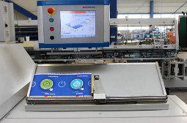**Smart Navidesk (Optional) –** Product measurements can be defined via the optional Smart Navidesk’s integrated measuring table which transfers to the Navigator. The Smart Navidesk captures product parameters to reduce makeready times and reduce fine tuning.

**Dynamic-Drive Technology –** Used for motorized positioning adjustments and clamping to increase product quality and flexibility. The Servo-drives are directly connected to the moving axes, reducing the number of moveable parts for less wear and tear and lower lifetime costs. There is no clutch. Set-up is automatic and takes less than 5 minutes.

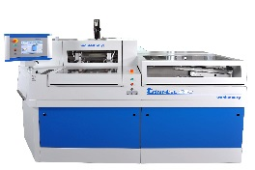**One Piece Machine Frame –** Engineered for improved running smoothness/stability, higher speeds and long-lasting cutting accuracy. Enhances the swinging shear cut on all three knives.

|  |
| --- |
| **For More Information**  +1 (262) 522-3330  [Sales@bestgraphics.net](mailto:Sales@bestgraphics.net)  [www.bestgraphics.net](http://www.bestgraphics.net) |

**Silicone Spray Device –** To prevent glue from sticking to the side knives. The number of cuts per spray can be selected in the Navigator.

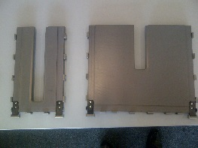**Reduced Number of Interchangeable Parts –** The only interchangeable parts are the format plate holders – made from aluminum – and the cutting tables, which both lock without any tools. There are no interchangeable parts for varying product heights and widths. These developments simplify the set-up process.

**Cutting Tables**

**Energy Savings –** Power consumption has been reduced by 20% compared to previous models. Dynamic-Drive Technology minimizes energy uses costs by using the generative energy of one drive to power another drive.

**Integrated Counter Stacker –** Can be used in either counter operation (discussed in the next section). The change between each operation takes less than a minute.

**Pusher Mode vs. Counting Mode**

The counter stacker has two counter operation modes. The mode used usually depends on product thickness. Changeover from pusher to counter mode takes less than a minute.

**Pusher Mode –** Automatic operating mode for products *over* 10mm (0.39”) thick. The product is stacked in the magazine. The height-adjustable delivery system “strips” the product based on the pre-defined stack height.

**Counting Mode –** Automatic operating mode for products *under* 10mm (0.39”) thick. The product is counted and stacked in the pre-stacking magazine. When the pre-defined number of products is reached, the magazine bottom flaps slide open. Then the product is transferred onto the infeed table and further on towards the clamping device.

**Specifications by Model**

|  |  |  |
| --- | --- | --- |
|  | **Trim-tec 60e** | **Trim-tec 90e** |
| **Mechanical Speed** | 500-3,600 cycles/hr. | 500-5,400 cycles/hr. |
| **Product Height** | Untrimmed:  5.51-14.56”  Trimmed:  5.43-14.48” | Untrimmed:  5.51-16.14”  Trimmed:  5.31-14.96” |
| **Product Width** | Untrimmed:  4.13-12.59”  Trimmed:  3.93-11.81” | |
| **Max Trim Height** | 2.75” | |

