Young Shin Die Cutters, Blankers & Foil Stampers – Since 1980
Young Shin, a South Korean manufacturer, has been producing and exporting Die Cutters for 40-years. With production facilities throughout Korea, wholly owned subsidiaries in the United States and Europe, and more than 100 installations throughout North America and 1,500 worldwide, Young Shin has become a growing presence in the Folded Carton, and Corrugated industries.
 | 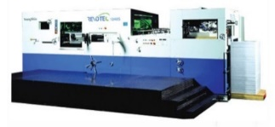  REVOTEC 1040S & 106SR | 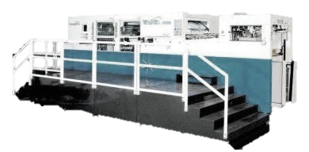  REVOTEC 106SB | 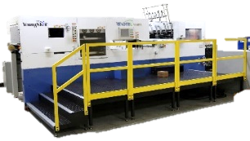  REVOTEC 1040FS | 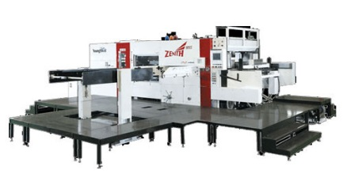  ZENITH & GIANT
Description | Flatbed Die Cutter | Die Cutter – Blanker | Die Cutter – Foil Stamper | Corrugated – Large Format
Speed  (sheets/hr.) | 7,500 sph | 8,000 sph | Foil Stamper: 5,000 sph  Die Cut-Strip: 6,600 sph | Zenith 185S: 6,000 sph  Zenith 210S Plus: 5,000 sph  Giant 210SII: 3,000 sph
Max Sheet Size | REVOTEC 1040S:  29.13” x 40.94”  REVOTEC 106SR:  29.92” x 41.73” | 29.92” X 41.73” | 29.13” x 40.94” | Zenith 185S: 72.83” x 43.54”  Zenith 210S Plus: 82.67” x 59.06”  Giant 210SII: 82.67” x 59.05”
Min Sheet Size | REVOTEC 1040S:  13.38” x 17.32”  REVOTEC 106SR:  13.38” x 15.75” | 13.38 x 17.32” | 13.38 x 17.32” | Zenith 185S: 23.62” x 19.69”  Zenith 210S Plus: 31.50” x 23.62”  Giant 210SII: 43.30” x 33.46”
Cutting Pressure | 330 U.S. Tons | 330 U.S. Tons | 330 U.S. Tons | Zenith 185S: 440 U.S. Tons  Zenith 210S Plus: 551 U.S. Tons  Giant 210SII: 550 U.S. Tons
Weight | REVOTEC 1040S:  19 U.S. Tons  REVOTEC 106SR:  21 U.S. Tons | 25 U.S. Tons | 22 U.S. Tons | Zenith 185S: 49 U.S. Tons  Zenith 210S Plus: 58 U.S. Tons  Giant 210SII: 37.5 U.S. Tons
Spike or Gripper | N/A | N/A | N/A | Zenith 185S: Gripper  Zenith 210S Plus: Gripper  Giant 210SII: Spike
Spike vs. Gripper | Gripper: Faster running speed.  Spike: More accurate registration. Less expensive to maintain.  Allow thinner corrugate to be die cut. Better at warped corrugated board.
Stripping? | Yes
Foiling Info | N/A | N/A | Foil Path: 6’  Max Foil Diameter: 7:  Foil Width: 1.18” – 40.15”  Pull Shafts: (3) Servo Driven  Rewind Shafts (2) Internal  Heating Zones: 12 | N/A
Electrical | REVOTEC 1040S:  240V, 3 Phase, 65 Amps  REVOTEC 106SR:  240V, 3 Phase, 100 Amps | 240V, 3 Phase, 100 Amps | 240V, 3 Phase, 150 Amps | Zenith 185S: 480V, 3 Phase, 100 Amps  Zenith 210S Plus: 480V, 3 Phase, 125 Amps  Giant 210SII: 480V, 3 Phase, 60 Amps
Sheet Thickness | Carton Board:  0.004” to 0.06”  Corrugated Board (E, B Flute):  0.157” | Paper Substrates:  0.004” to 0.06”  Corrugated Board (EB Flute):  0.157” | 0.004” to 0.06” & B Flute | Zenith 185S:  Corrugated Board (E, B, A, AB Flute) 0.06” ~ 0.43”  Zenith 210S Plus:  Corrugated Board (E, B, A, AB Flute) 0.05” ~ 0.43”  Giant 210SII:  Corrugated Board (E, B, A, AB Flute) 0.05” ~ 0.43”
Inside Chase | REVOTEC 1040S:  30.07” x 43.30”  REVOTEC 106SR:  29.68” x 44.88” | 29.68″ x 44.88” | 30.07” x 43.30” | Zenith 185S:  74.89” x 45.28”  Zenith 210S Plus:  85.04” x 60.28”  Giant 210SII:  72.83” x 52.12”
Options | REVOTEC 106SR:  Automatic Apron – Non-Stop Delivery | Pre-Makeready Table for Chase  Power Register System | Pre-Makeready Table for Chase  Case Changer  Exclusively Stamping Machine with Larger Diameter Rolls  External Foil System | Zenith 185S & Zenith 210S Plus:  Semi-Automatic Pro-Feeder  Giant 210SII:  Gripper Edge Removal Device  Batch Delivery System

